Year Group | Autumn 1 | Autumn 2 | Spring 1 | Spring 2 | Summer 1 | Summer 2
EYFS | Body Management | Gymnastics | Manipulation and Co-Ordination | Dance | Cooperate and Solve Problems | Speed and Agility Travel
1 | Attack, Defend and Shoot | Gymnastics | Send and Return | Hit, Catch and Run  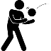 | OAA  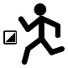 | Run, Jump and Throw
2 | Attack, Defend and Shoot | Gymnastics | Send and Return | Hit, Catch and Run | OAA | Run, Jump and Throw
3 | Cricket | Dance | Handball | Tennis | Basketball | Athletics
4 | Cricket | Dance | Handball | Tennis | Basketball | Athletics
5 | Rounders | Gymnastics | Netball  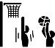 | Badminton  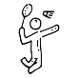 | Football | Athletics
6 | Rounders | Gymnastics | Netball | 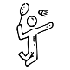  Badminton | Football | Athletics

